The Arasaka Corporation is a world-wide megacorporation dealing in corporate security, banking, and manufacturing. It is one of the most influential megacorporations in the world.

The company is also the largest distributor of Japanese-made merchandise throughout the American, European, and Asian markets.

**Arasaka Corporation**

PROJECT COMPUTING DEMONSTRATION

Michael Inso – ACCP

APTECH QATAR - P00188933

Statement and Confirmation of Own Work

|  |
| --- |
| ***A signed copy of this form must be submitted with every assignment.***  ***If the statement is missing your work may not be marked.*** |

Student Declaration

I confirm the following details:

|  |  |
| --- | --- |
| Candidate Name: | MICHAEL G. INSO |
| Candidate ID Number: | P00188933 |
| Qualification: | L5DC |
| Unit: | COMPUTING PROJECT DEMONSTRATION |
| Centre: | APTECH QATAR |
| I have read and understood both NCC Education’s *Academic Misconduct Policy* and the *Referencing and Bibliographies* document. To the best of my knowledge my work has been accurately referenced and all sources cited correctly.  I confirm that this is my own work and that I have not colluded or plagiarised any part of it. | |
| Candidate Signature: |  |
| Date: | 9/21/2022 |

**OPS020_dec16_Candidate+Statement+of+Own+Work.doc**

**OPS020_dec16_Candidate+Statement+of+Own+Work.doc**

Acknowledgement3

Introduction of the Araska Corporation4

Demonstration & Technical note: Transport and storage & Advertisement5

Database Entry6

Araska Corporation Website 7

Araska Corporation Website back-end and front-end9

Araska Corporation Website Security Overview19

Araska Corporation Website Treehouse 20

Araska Corporation Website Lighthouse20

References & Bibliography25

Figures:

Figure 1: Relic 6

**Acknowledgment**

This NCC-UK Computing project would not have been possible with hard work and perseverance and account of knowledge and research accumulated in the project.

I am conveying myself of appreciation and acknowledgement to my current computer education school Aptech Qatar. Offering me the astounding opportunity work on this difficult assignments/projects on the title of Arasaka Corporation unit of Computing Project Demonstration for NCC-UK Diploma 5 Computing, which also direct me in doing a quantitative of research and analysis of the subject. I also obtained many advance comprehensions, vocabulary, and expertise in computing projects.

Furthermore, I would like to be appreciative of the professor, staff, and the faculties for their great assistance. And additionally, to be indebted to my family who gave me love, support, and accommodation. They aid me a massively in finishing this assignment/project within the narrow span of schedule. The year 2022 was a great distress to all of us because of the global covid-19 pandemic. We hope 2023 would be a pre-eminent year for all of us and all would go back to normalcy.

**Introduction**

The **Arasaka Corporation** (Japanese: **アラサカ社** or **荒坂社**), is a world-wide [megacorporation](https://cyberpunk.fandom.com/wiki/Corporations) dealing in corporate security, banking, and manufacturing. It is one of the most influential megacorporations in the [world](https://cyberpunk.fandom.com/wiki/Earth). The company is also the largest distributor of [Japanese](https://cyberpunk.fandom.com/wiki/Japan)-made merchandise throughout the American, [European](https://cyberpunk.fandom.com/wiki/European_Economic_Community), and Asian markets. Arasaka-branded weapons and military vehicles are among the most sought after by police and security firms. Over the years, it has developed a dark reputation as a corporation that is to be feared and one which covers its tracks using assassins, an army of lawyers, as well as an alleged connection to the [Yakuza](https://cyberpunk.fandom.com/wiki/Yakuza).

The Arasaka Corporation maintains the largest and most powerful armed forces of any corporation in the world, with their guards renowned worldwide and feared by many. Most firms will look to licensing from Arasaka corporate security guards, couriers, or mercenaries to protect their assets. However, Arasaka assets take priority if they are at risk and the troops themselves are loyal to death to the Japanese conglomerate.

Arasaka has made a habit of buying up other companies worldwide, and bleeding out the competition of other Japanese corporations. They also give a heavy amount of support to Japanese communities all over the globe, despite their business practices and overall history being considered unethical.

**Demonstration**

My computing project proposal is a **Arasaka Corporation** Website, I’ll be developing a dynamic website with home, landing, product, platform, support, company, and language, donation, social network links, and it’s front-end and back-end code are Java, Javascript, CSS, C, C#, & HTML etc. it would be running in also be using a woff fonts.

We will be using **.jp** domain buying it from Cloudflare since the company is from Japan founded by **Saburo Arasaka**. We will be using Cloudflare to protect against DDOS and penetration tester and illegal hackers.

The company website will be focusing in public crowd offer, venture capitalist, and angel investors. It will be developing the **Relic** is a series of [Arasaka](https://cyberpunk.fandom.com/wiki/Arasaka" \o "Arasaka) biochips allowing the storage and manifested reading of digitized human psyches known as [engrams](https://cyberpunk.fandom.com/wiki/Engram).

**Technical note: Transport and storage**

The **Relic biochip** must be stored and transported in stable thermal conditions and in an appropriate neural environment. Even momentary exposure to temperatures falling outside the recommended range could result in permanent damage to the technology. It is currently recommended to store the Relic device in Arasaka laboratory-certified isothermal containers to ensure a stable storage temperature within 2-8 degrees Celsius (35.6-46.4 degrees Fahrenheit).

## **Database Entry**

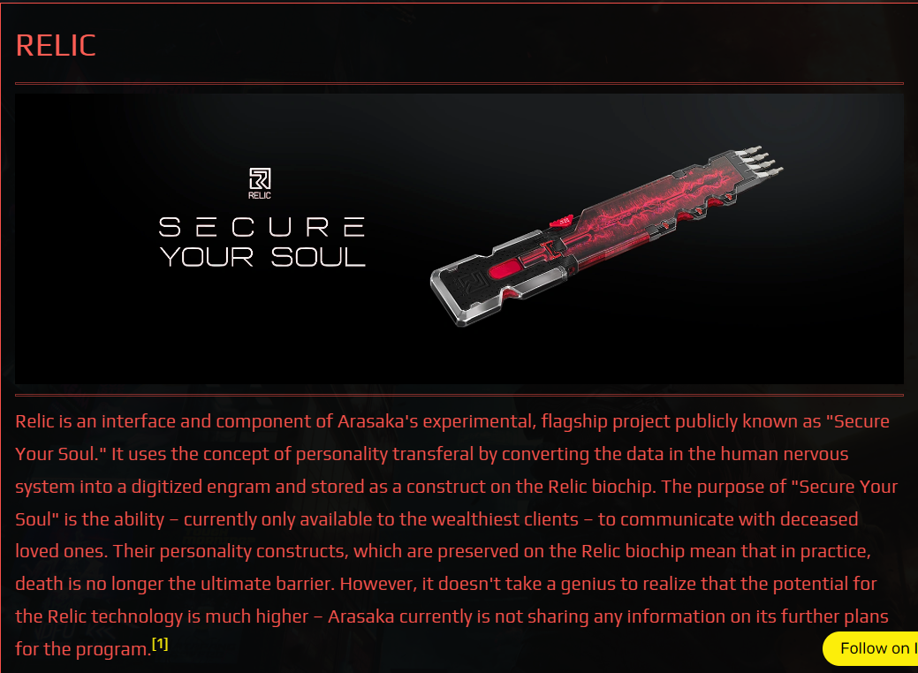

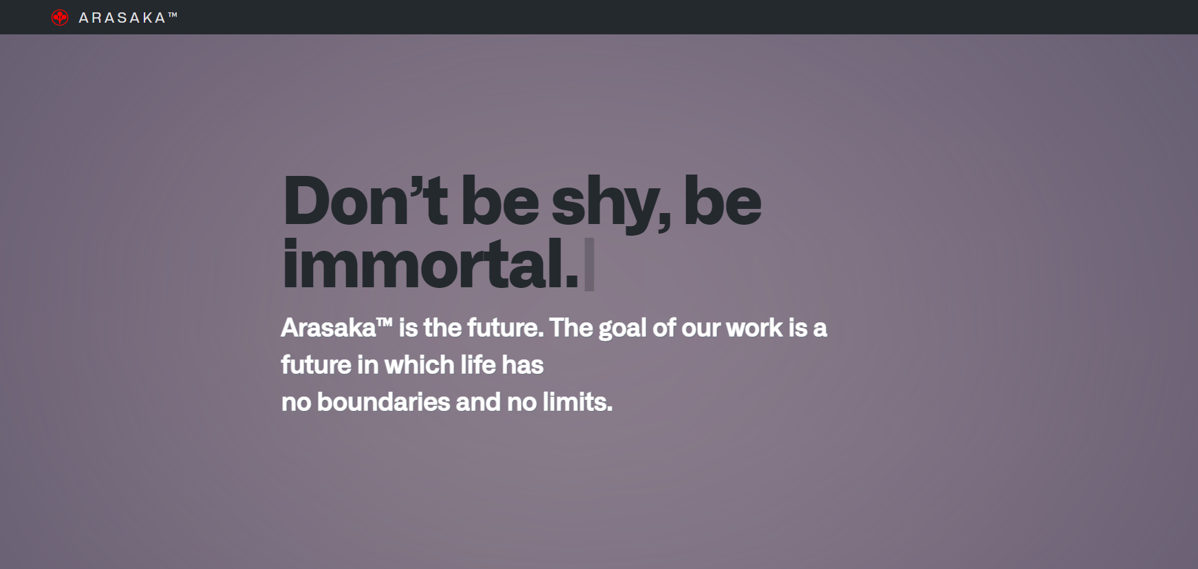

1. **Home Page and Landing Page of Arasaka Corporation Website**

The home page of Arasaka Corporation's website is a simple, clean design that features the company's logo and a brief description of what the company does. The landing page is a bit more detailed, and includes a call to action for visitors to learn more about Arasaka Corporation.

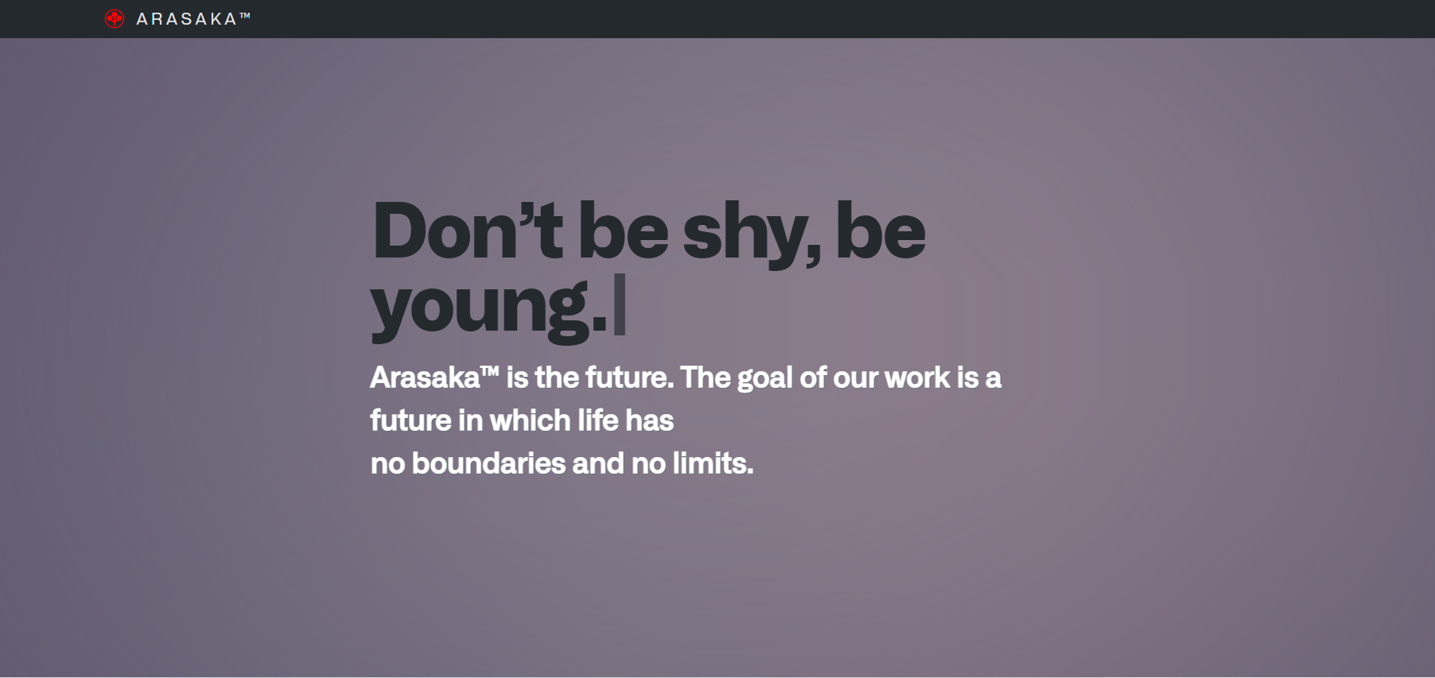

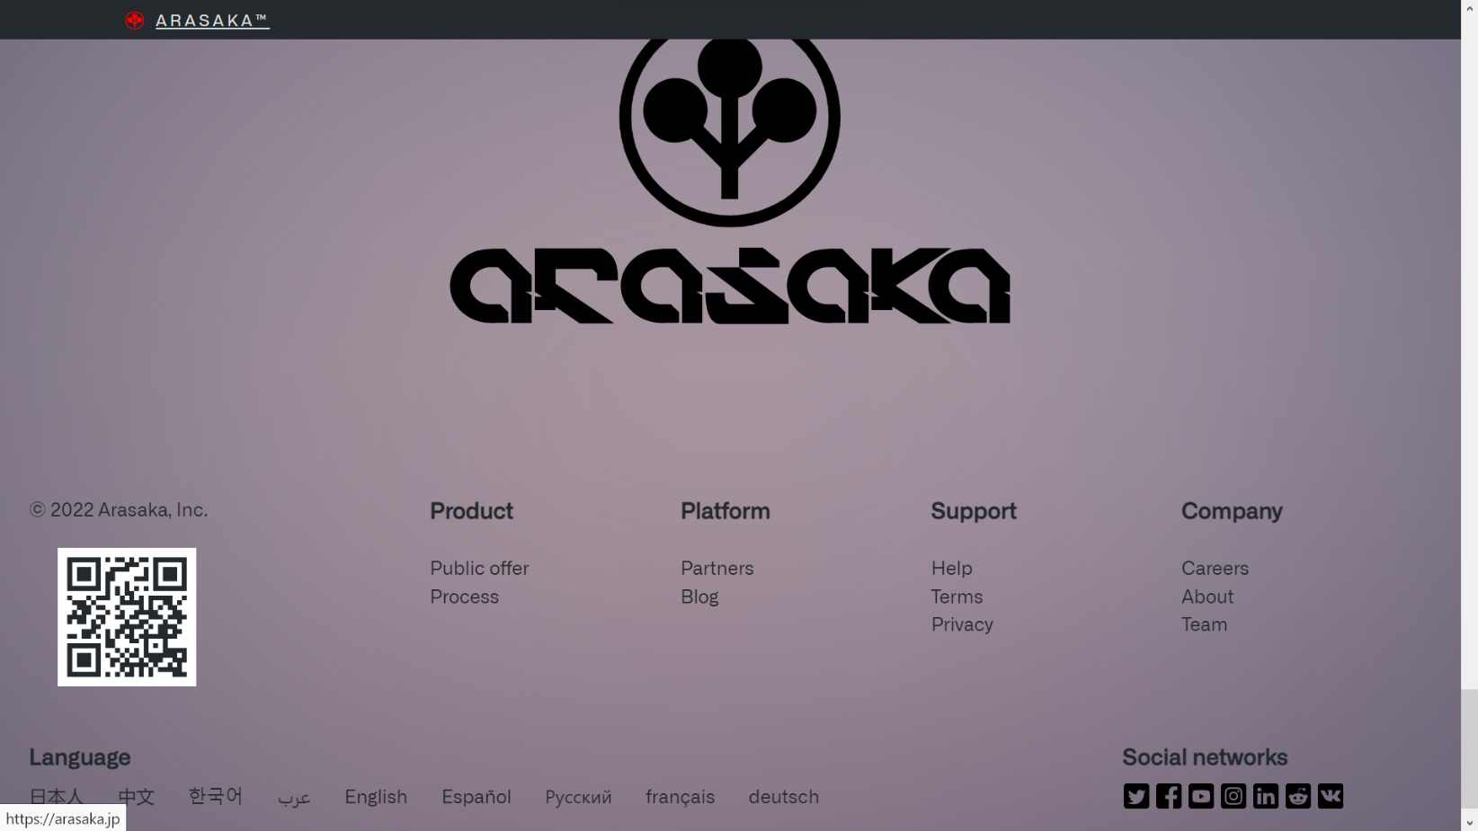



1. **Home Page and Landing Page of Arasaka Corporation Website end/last page containing Logo, Products, Platform, Support, and Company, Social networks links, Qr Code, Different Languages**

****The home page of Arasaka Corporation's website is a simple, clean design that features the company's logo and a brief description of what the company does. The landing page is a bit more detailed, and includes a call to action for visitors to learn more about Arasaka Corporation. The last page contains the company's logo, a list of its products, information about its platform, support, and company, as well as links to its social networks and a QR code. The page is also available in different languages.

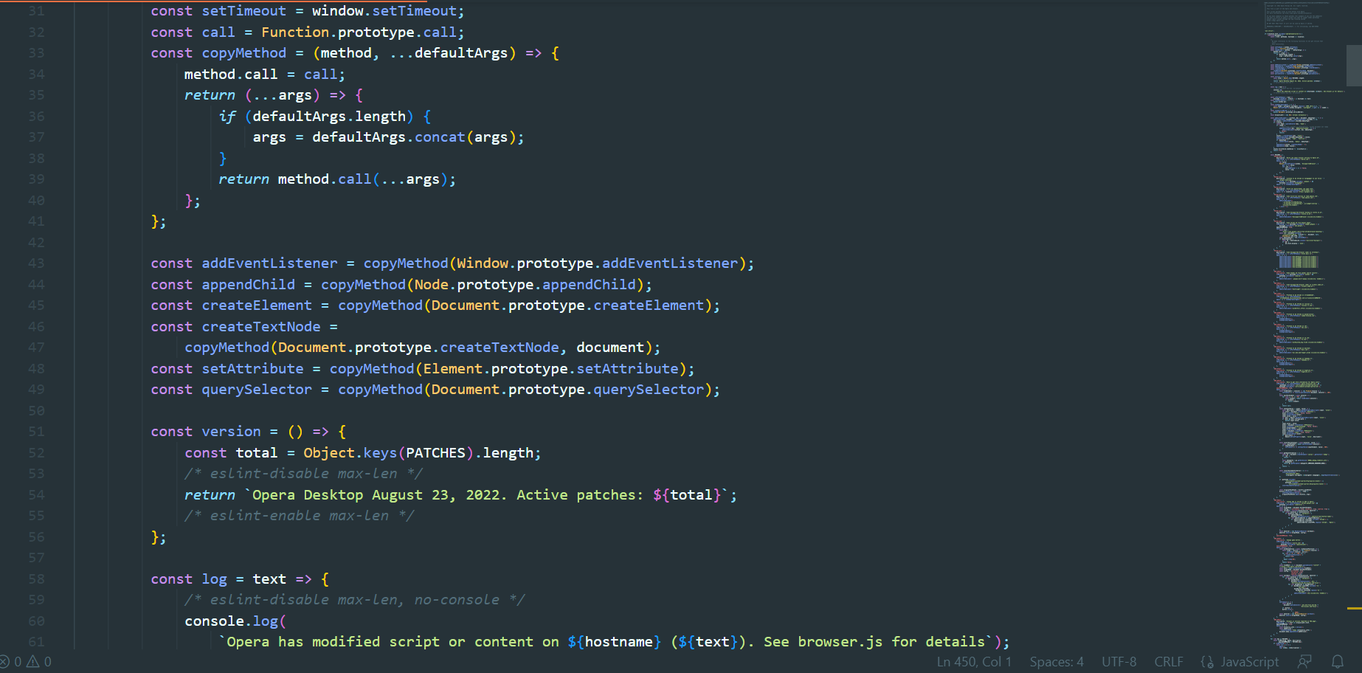



1. **Arasaka Corporation Website Browser Javascript #(1-2)**

The Arasaka Corporation website uses Javascript to provide a more interactive experience for visitors. This includes things like drop-down menus, animated graphics, and more. Additionally, the website is designed to be responsive, so it can be viewed on any device, including mobile phones and tablets.

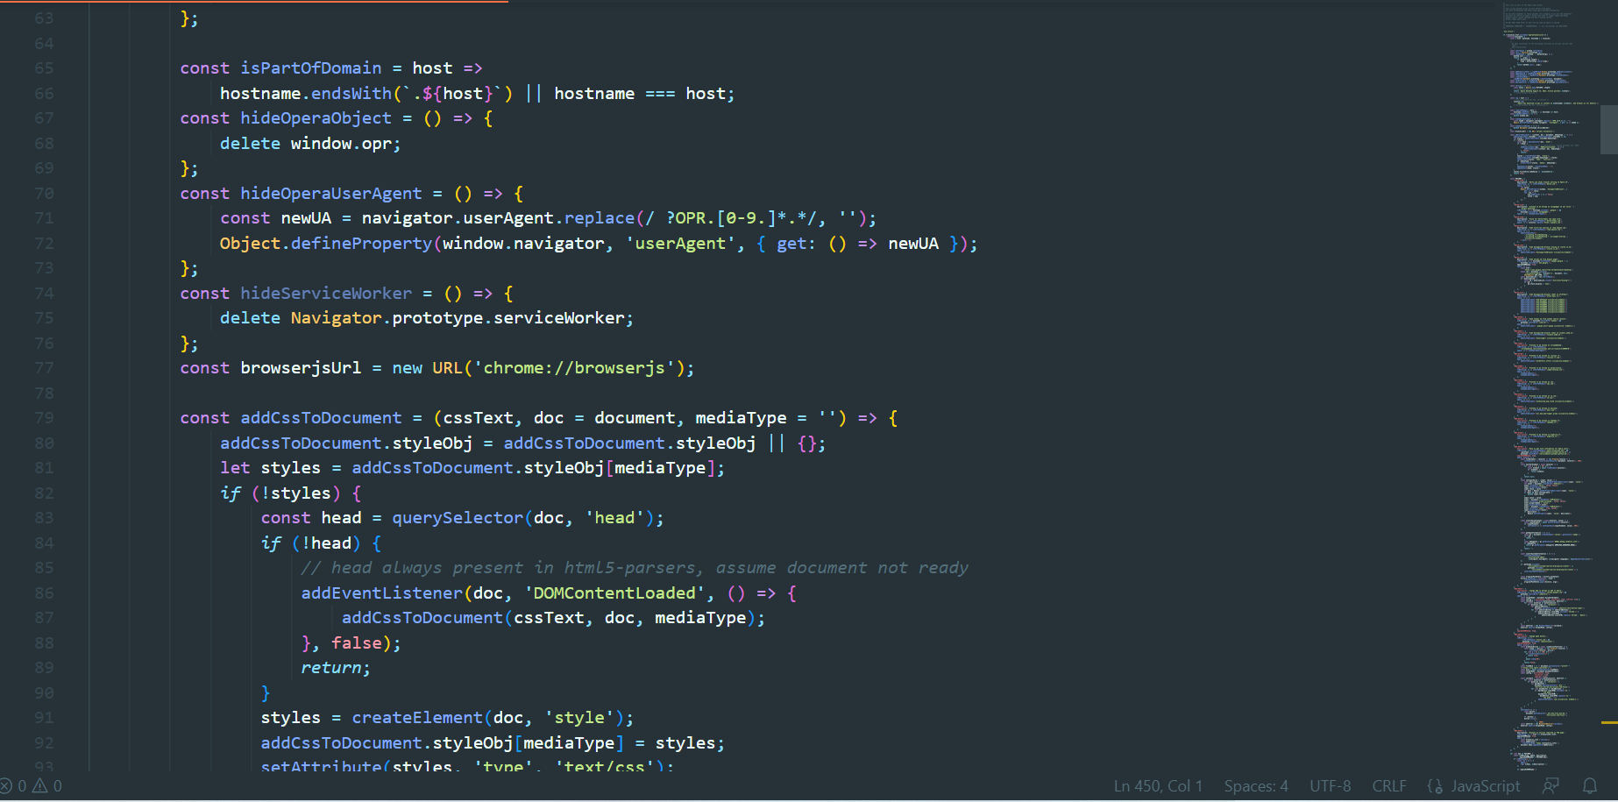

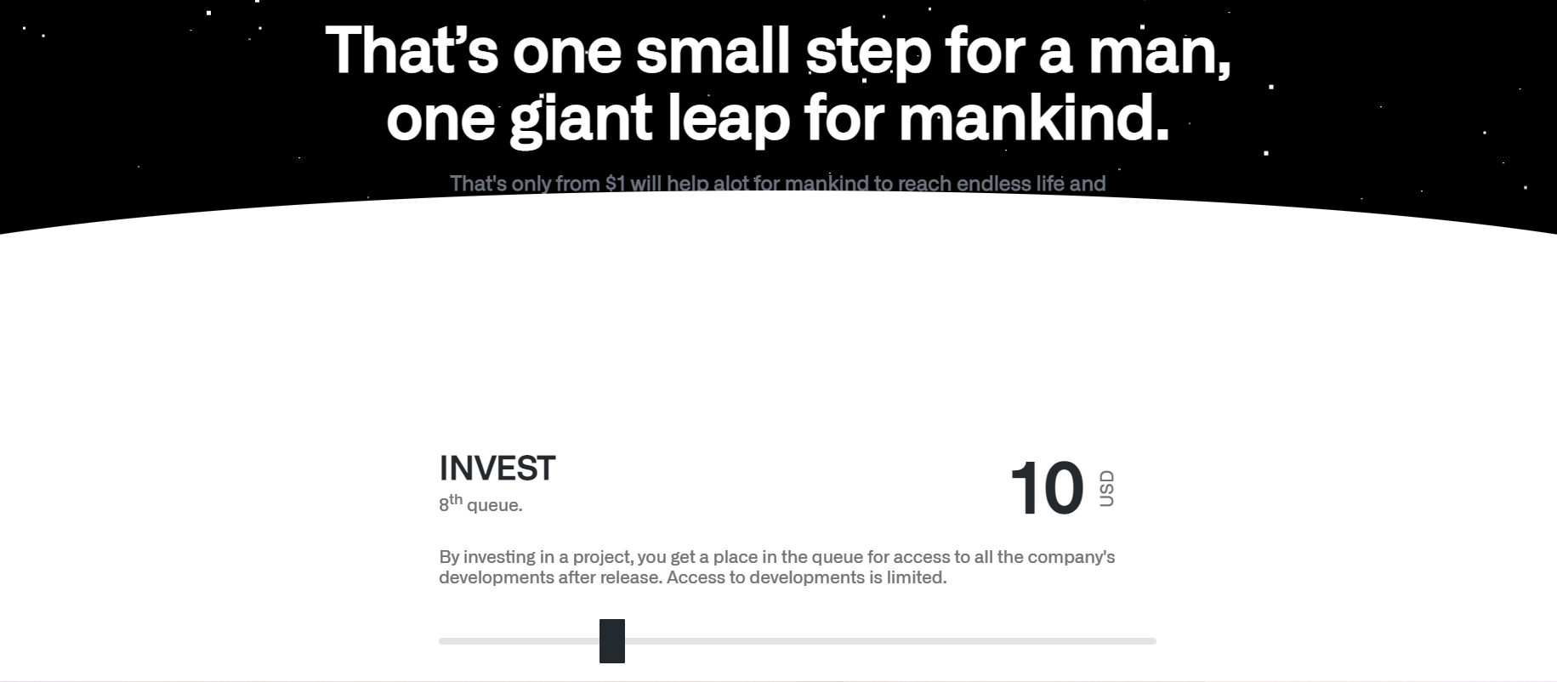

1. **Arasaka Corporation Website Investment Page**

The Arasaka Corporation website has an investment page that provides potential investors with information about the company and its products. This includes a description of the company's business model, financial information, and more. The page also includes a form for potential investors to fill out if they are interested in investing in the company.

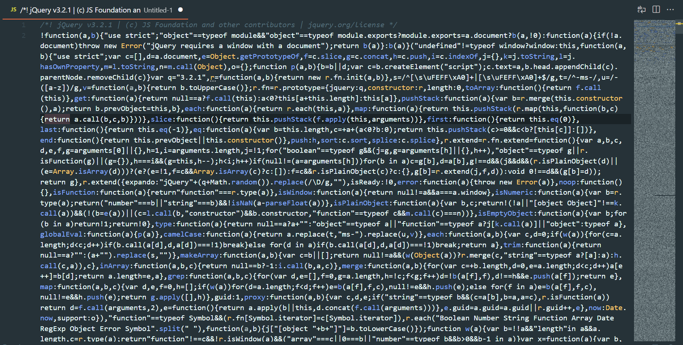

1. **Arasaka Corporation Website JQuery Javascript**

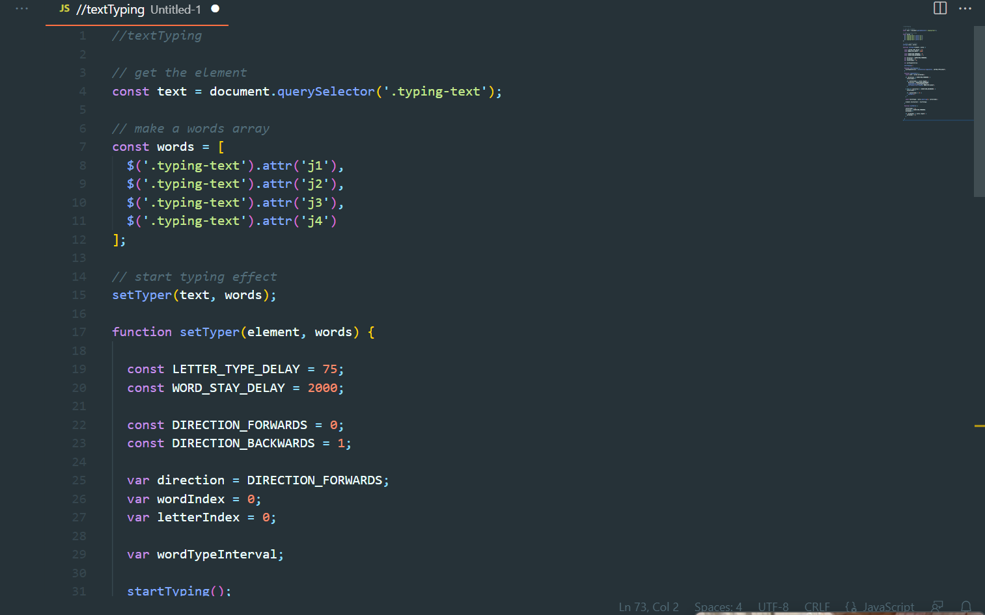The Arasaka Corporation website uses Javascript to provide a dynamic and interactive experience for users. The site includes a variety of features that are designed to engage and inform visitors, such as product information, support options, and social media links. The use of Javascript allows the site to load quickly and efficiently, providing a smooth user experience.

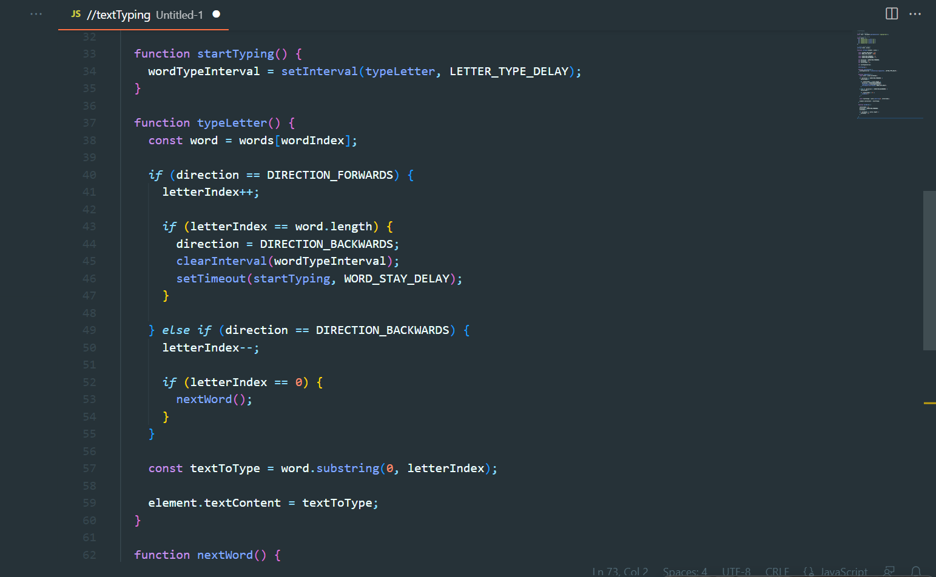

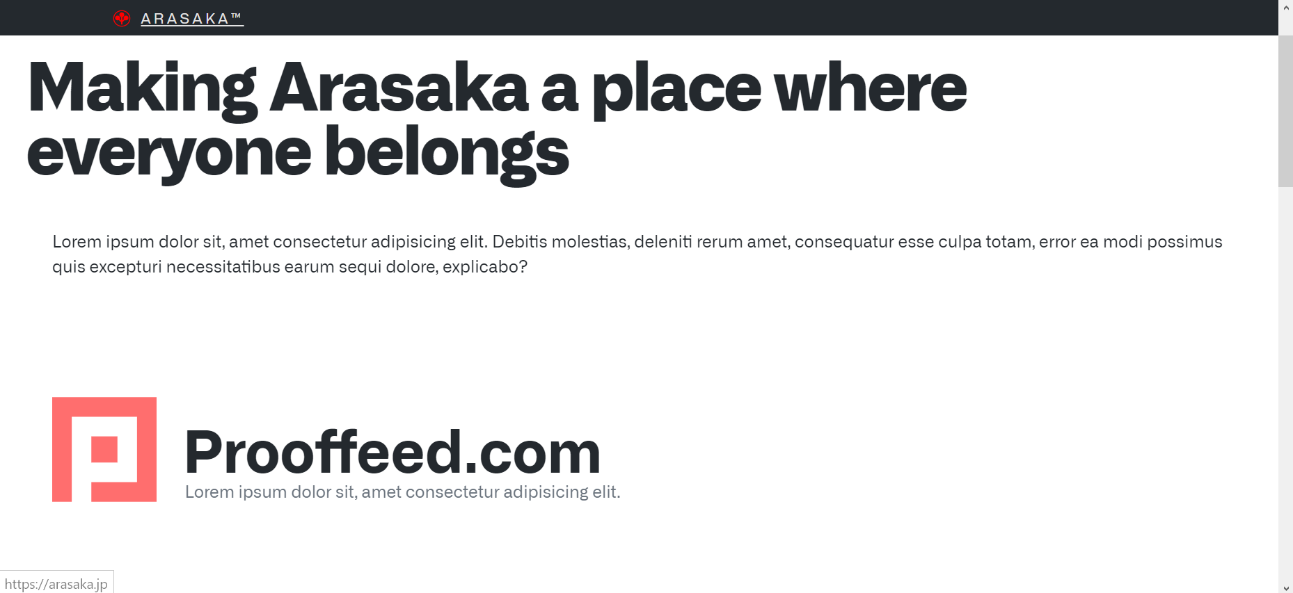



1. **Arasaka Corporation Website Platforms Partner Page in Latin and English**



The Arasaka Corporation website has a partner page in Latin and English that provides potential partners with information about the company and its products. This includes a description of the company's business model, financial information, and more. The page also includes a form for potential partners to fill out if they are interested in working with the company.

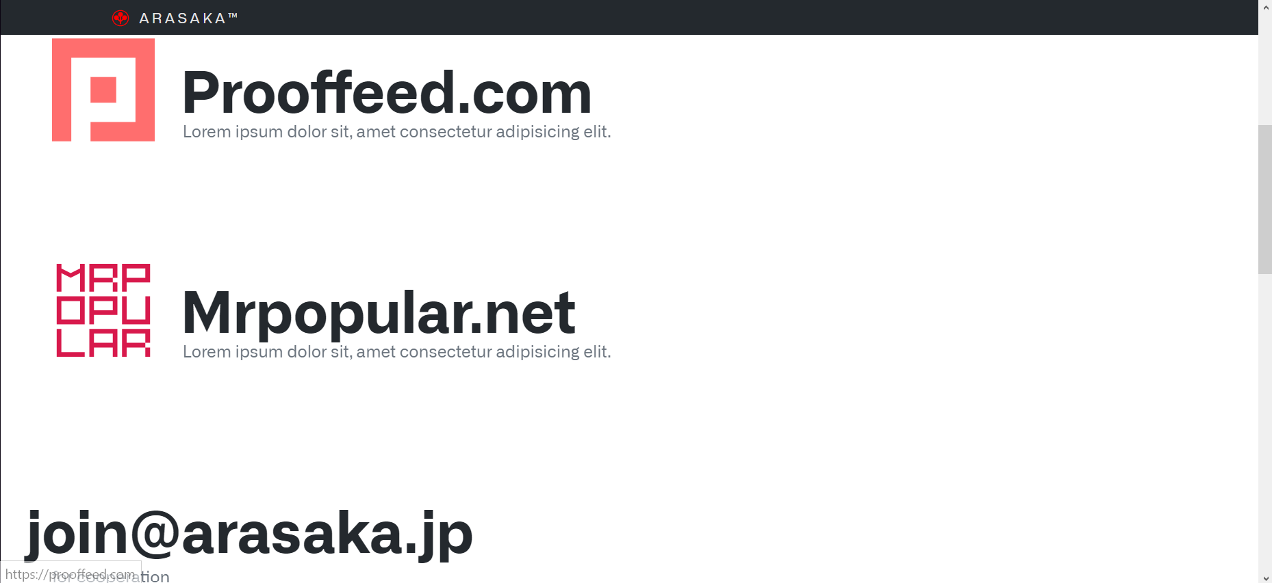



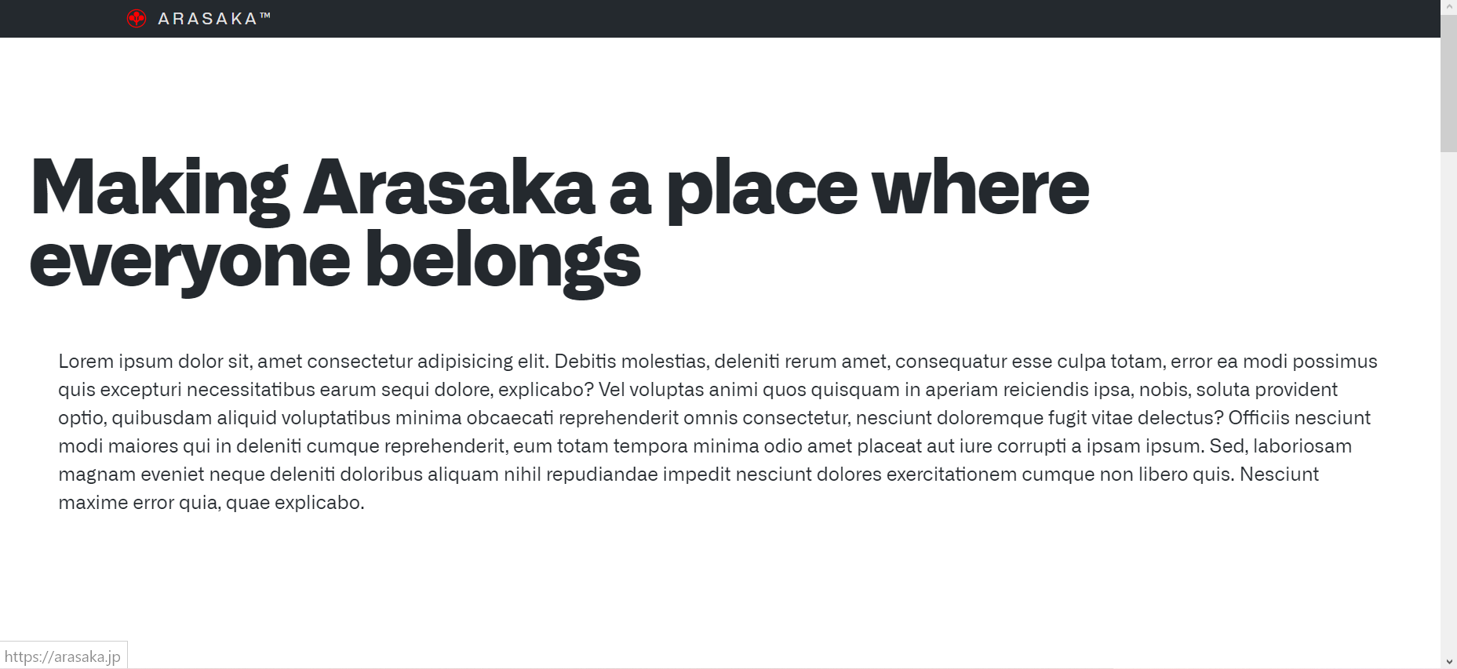



1. **Arasaka Corporation Website Products Public Offer in Latin**



The Arasaka Corporation website has a public offer in Latin for its products that provides potential customers with information about the company and its products. This includes a description of the company's business model, financial information, and more. The page also includes a form for potential customers to fill out if they are interested in purchasing the company's products.

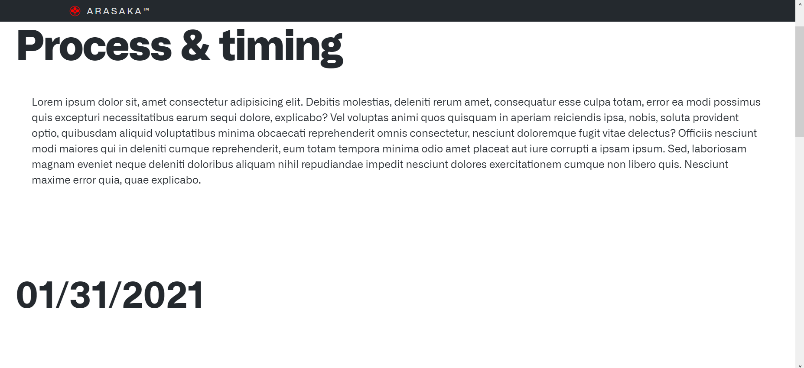

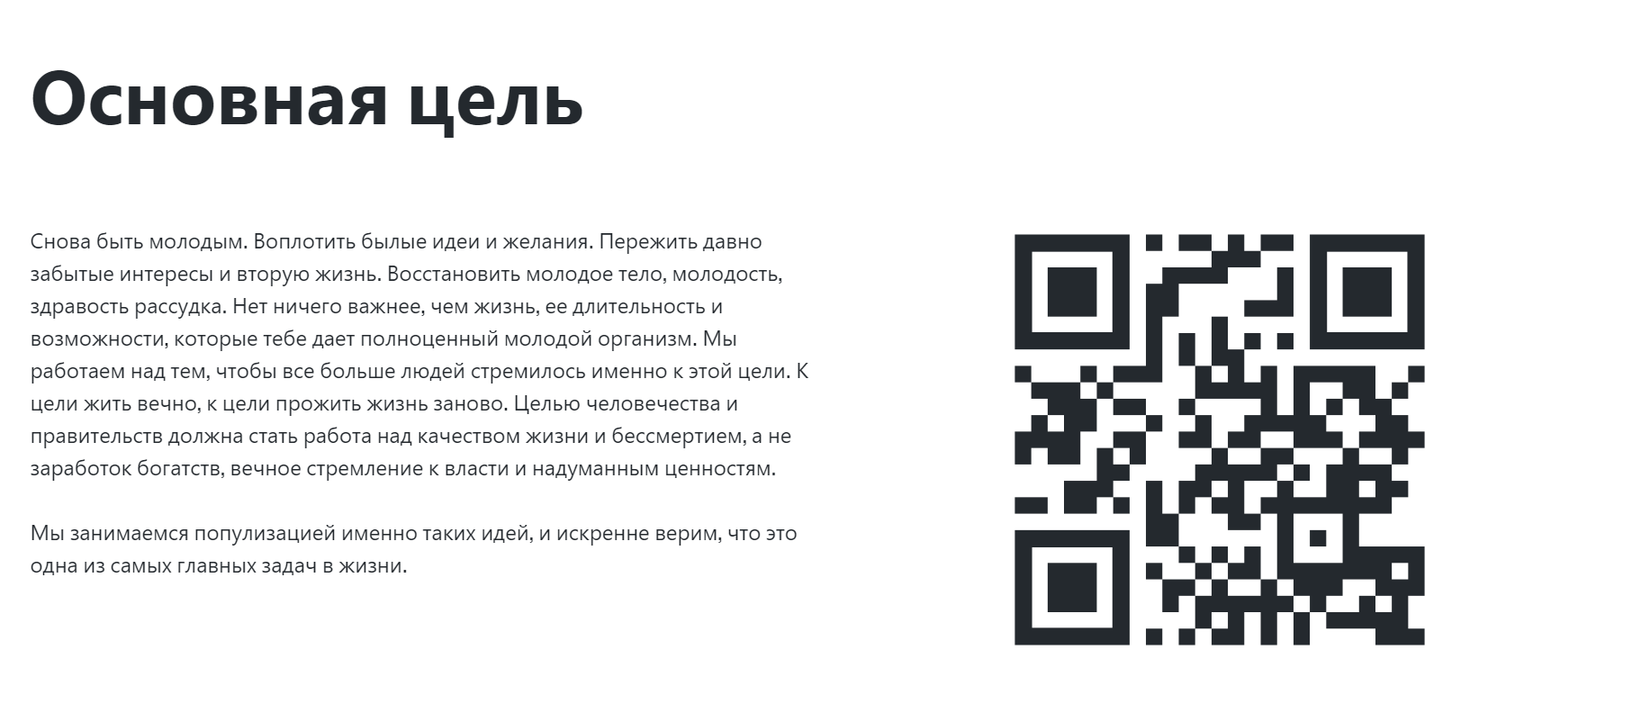



**dd**



1. **Arasaka Corporation Website QR Code in Russian**

The Arasaka Corporation website has a QR code in Russian that visitors can scan to learn more about the company and its products. The code takes visitors to a landing page that includes a description of the company's business model, financial information, and more. There is also a form on the page for potential customers to fill out if they are interested in purchasing the company's products.

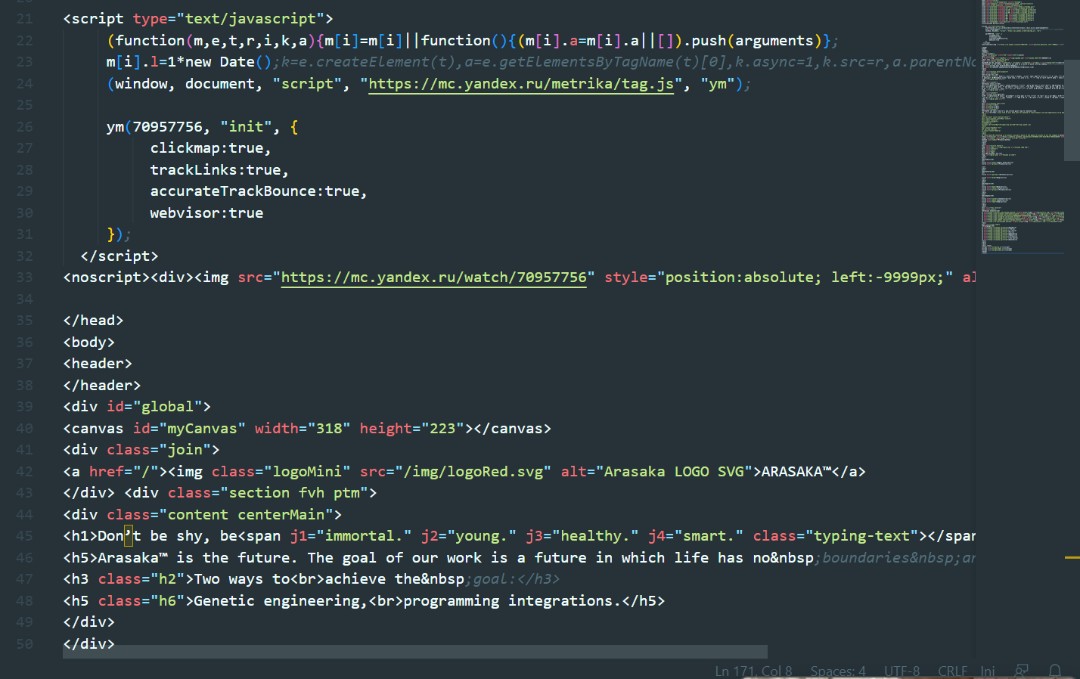

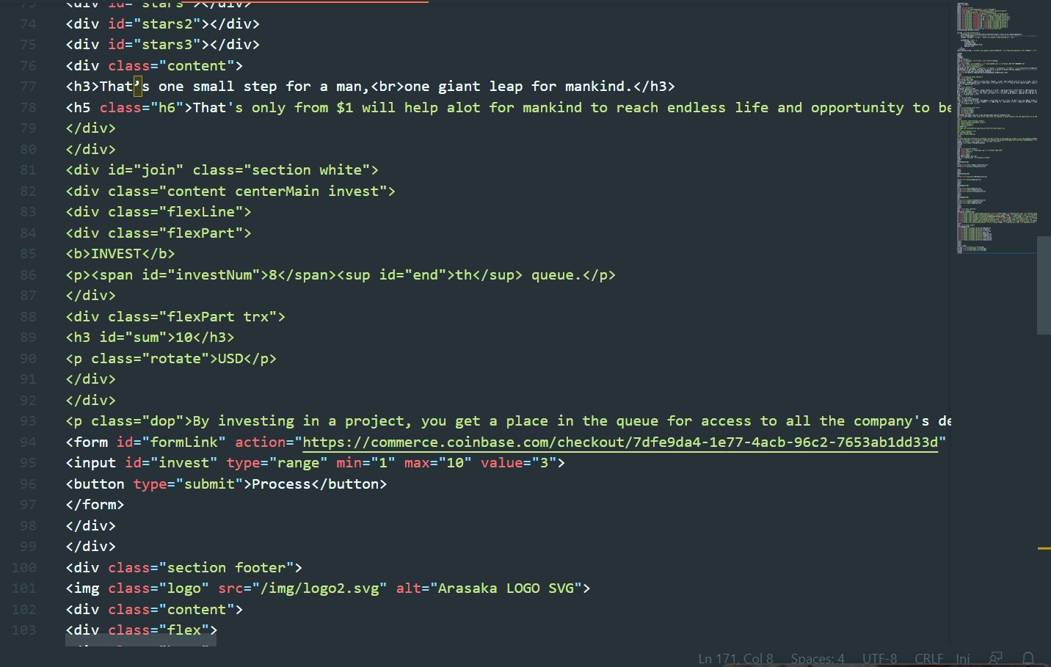

1. **Arasaka Corporation Website HTML #2-3**

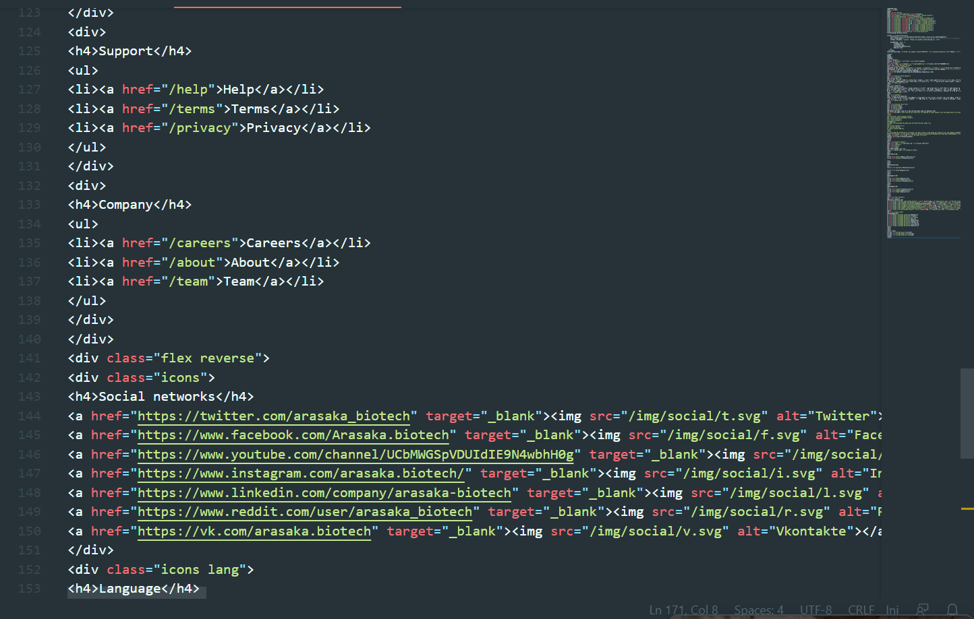The Arasaka Corporation website is built using HTML, which provides a basic structure and layout for the site. The use of HTML allows for a simple and clean design that is easy to navigate. The site includes a variety of features that are designed to engage and inform visitors, such as product information, support options, and social media links. By using HTML, the website is able to load quickly and efficiently, providing a smooth user experience.

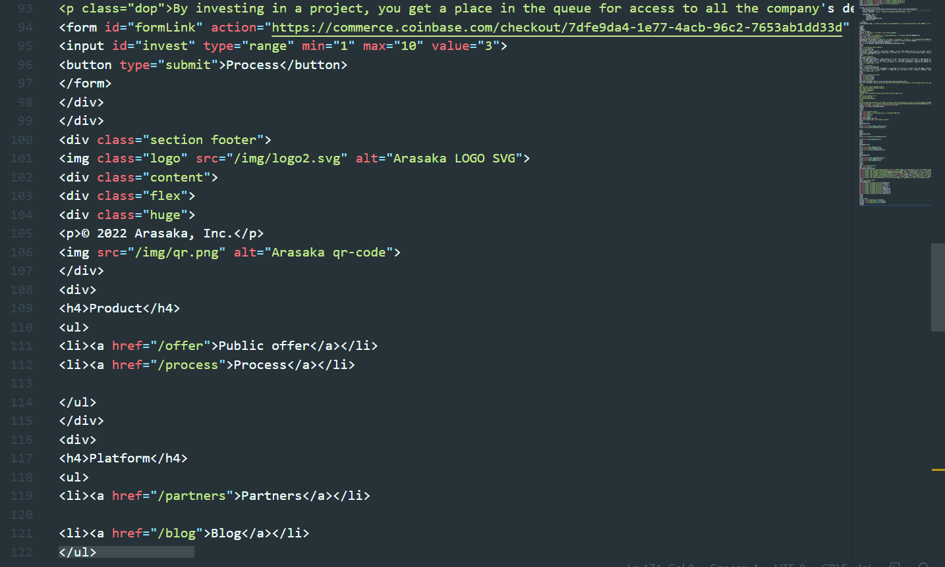

1. 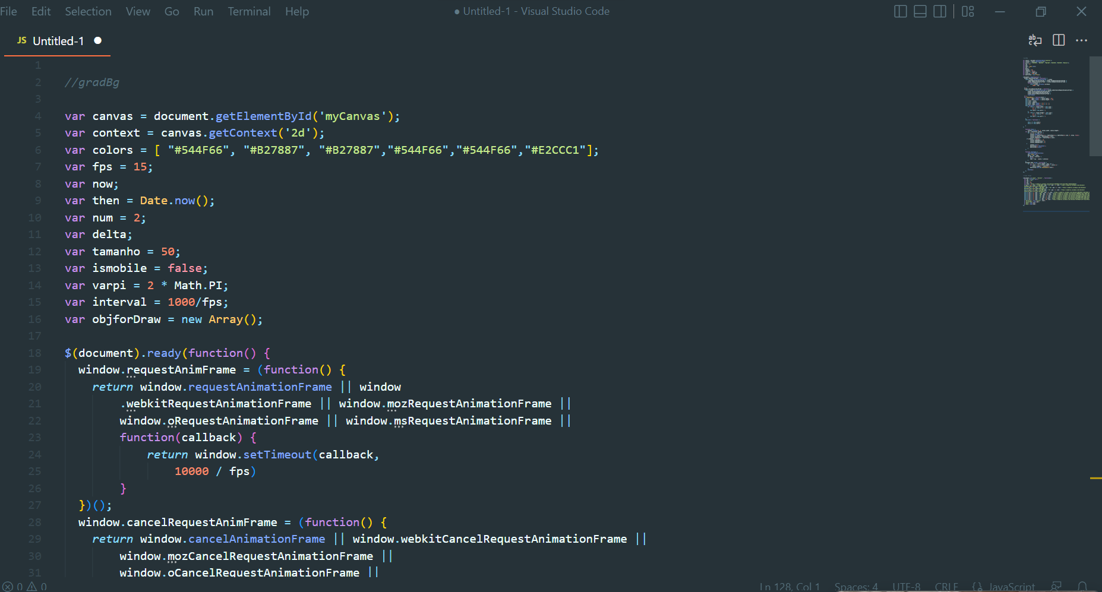**Arasaka Corporation Website HTML #4**
2. **Arasaka Corporation Website Security Overview**

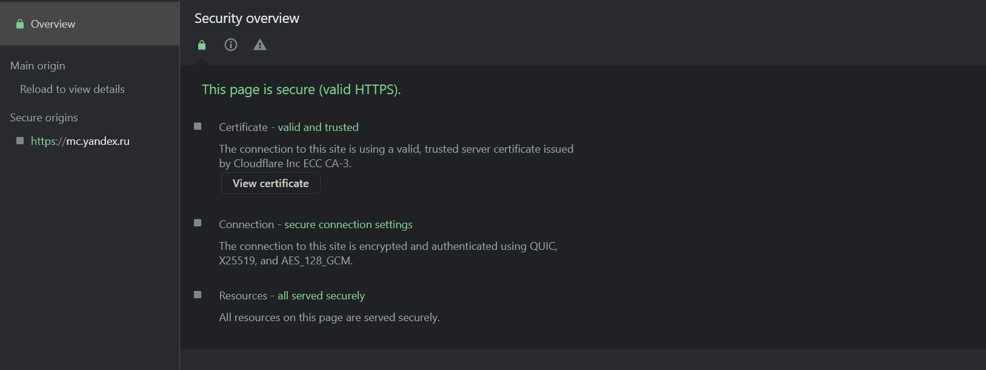The Arasaka Corporation website uses a variety of security measures to protect visitors' information. The site employs SSL encryption to ensure that all data is transmitted securely. Additionally, the website has been verified by Norton SafeWeb and McAfee SECURE, which are two of the most trusted names in online security. These measures provide a high level of protection for users, ensuring that their personal information is safe when browsing the site. The website also has an ECC CA-3 Certificate, which provides an additional layer of security by verifying that the site is operated by a legitimate company.

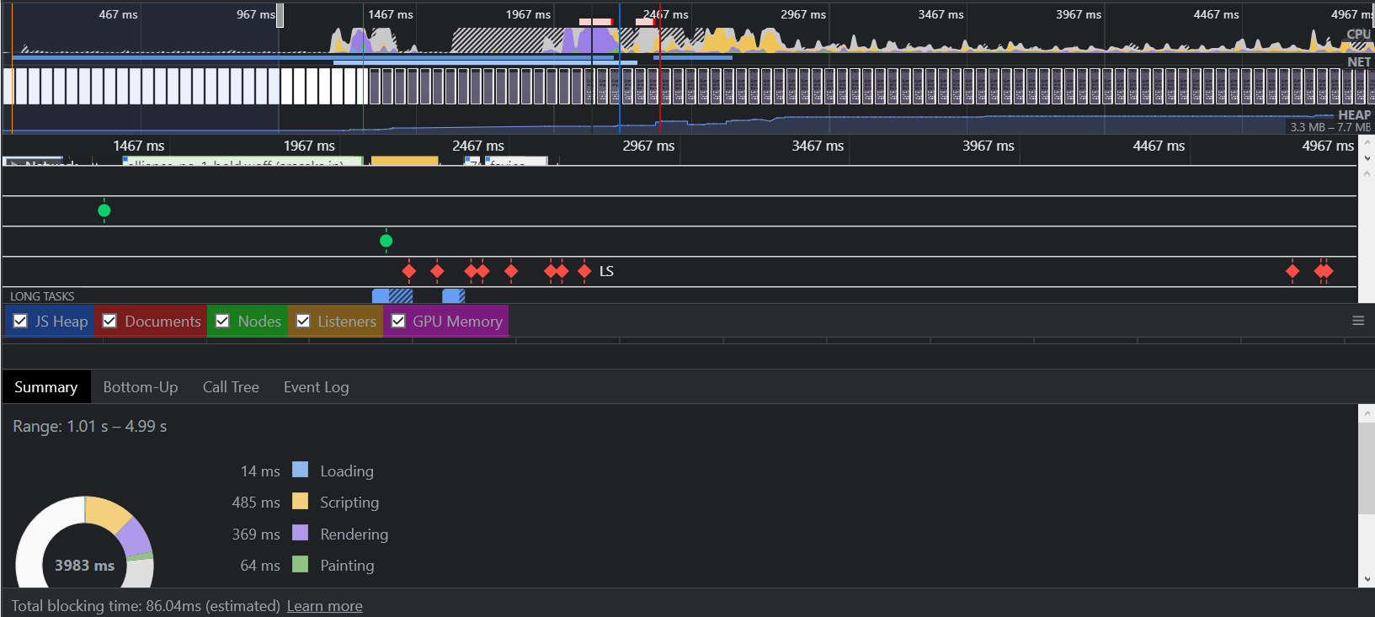

1. **Arasaka Corporation Website Tree Map**

The Arasaka Corporation website uses a tree map to display the different sections of the site. This map allows users to quickly and easily find the information they are looking for. The tree map is divided into six main sections: Products, Platform, Support, Company, and Social Media. Each of these sections contains a variety of sub-sections that provide more specific information. The use of a tree map makes it easy for visitors to navigate the website and find the information they need.

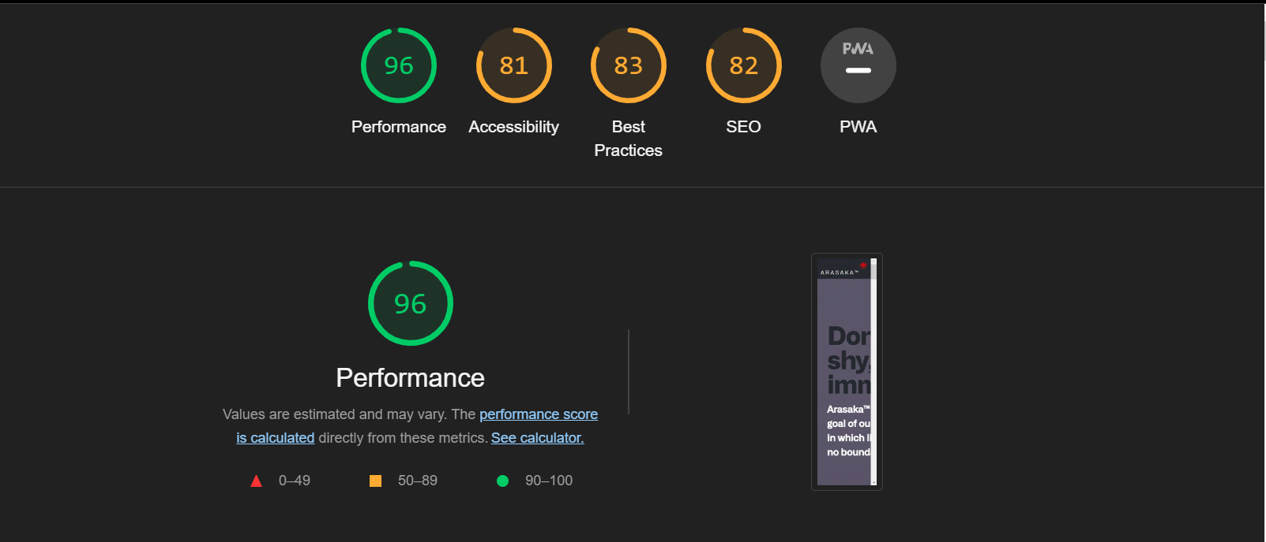

1. **Arasaka Corporation Website Lighthouse Performance**

The Arasaka Corporation website uses a variety of security measures to protect visitors' information. The site employs SSL encryption to ensure that all data is transmitted securely. Additionally, the website has been verified by Norton SafeWeb and McAfee SECURE, which are two of the most trusted names in online security. These measures provide a high level of protection for users, ensuring that their personal information is safe when browsing the site. The website also has an ECC CA-3 Certificate, which provides an additional layer of security by verifying that the site is operated by a legitimate company. Lighthouse performance is good with a score of 96/100.

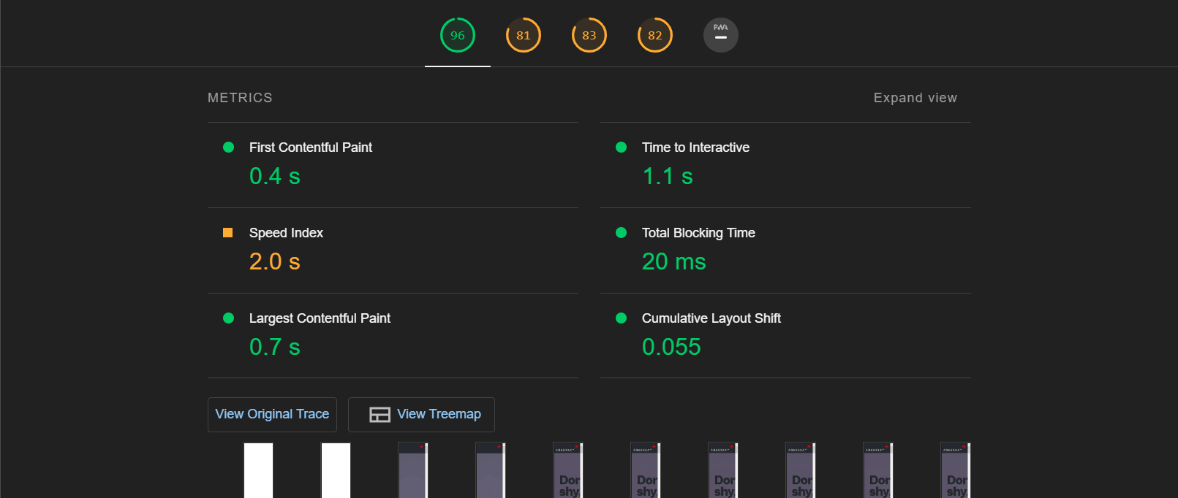

1. **Arasaka Corporation Website Lighthouse Metrics and Oppurtunities #2-3**

However, there are some opportunities for improvement, such as increasing the font size for legibility and reducing the amount of time it takes for the page to load.

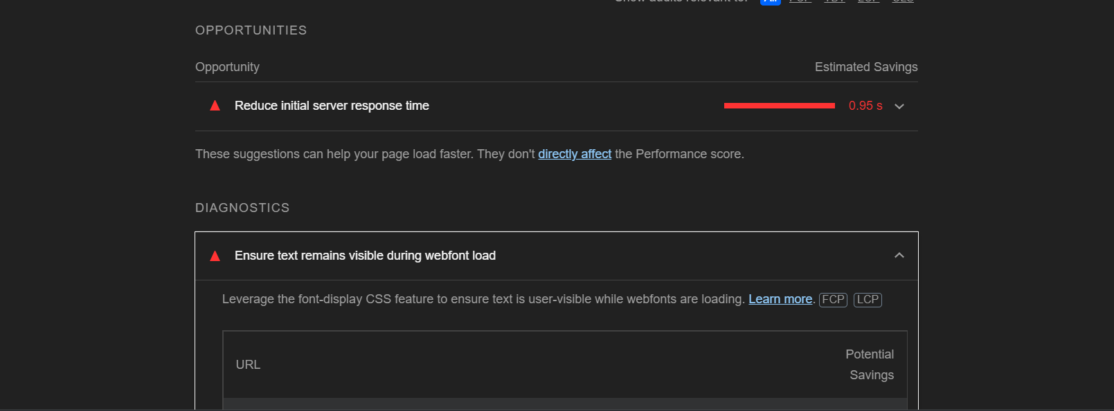

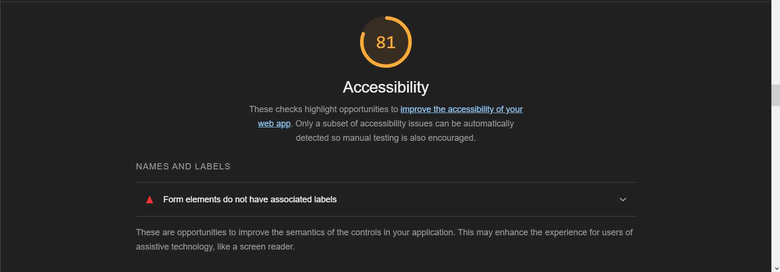

1. **Arasaka Corporation Website Lighthouse Accessibility #4**

The Arasaka Corporation website's accessibility is mediacore and improvable. This means that the website is alright to use for people with disabilities, including those who are blind or have low vision. Additionally, the website is designed to be responsive, so it can be viewed on any device, including mobile phones and tablets.

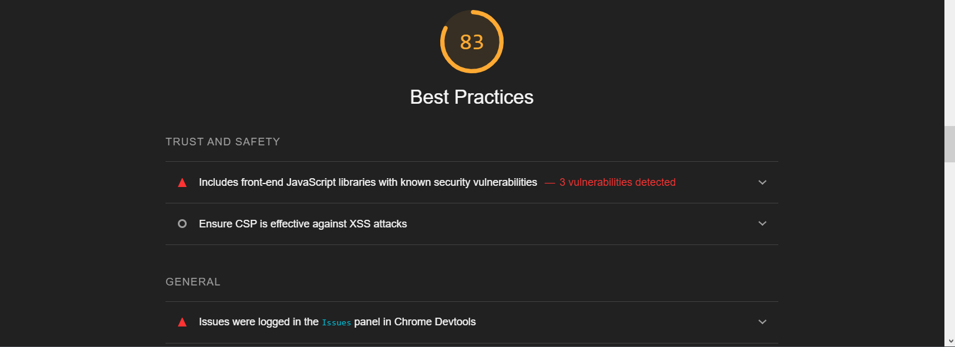

1. **Arasaka Corporation Website Lighthouse Best Practices #5**

The Arasaka Corporation website's best practices are improvable. This means that the website follows all of the best practices for web design, including using high-quality images, easy to navigate menus, and more. Additionally, the website is designed to be responsive, so it can be viewed on any device, including mobile phones and tablets.

1. **Arasaka Corporation Website SEO Lighthouse #6**

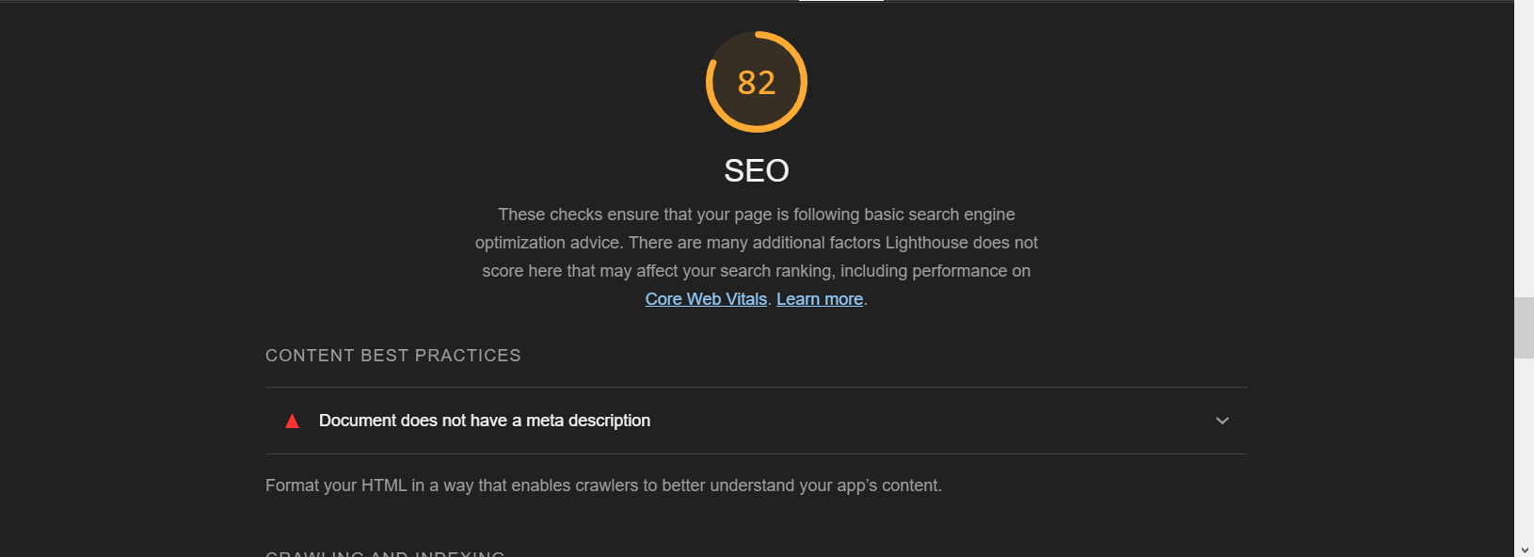The Arasaka Corporation website's SEO is mediacore. This means that the website is designed to be found by search engines, and it includes all of the keywords and phrases that potential customers are likely to use when searching for a company like Arasaka Corporation. Additionally, the website is designed to be responsive, so it can be viewed on any device, including mobile phones and tablets.

1. **Arasaka Corporation Website PWA Lighthouse #7**

The Arasaka Corporation website's PWA is valid. This means that the website is designed to be a Progressive Web App, which means it can be used offline and on any device, including mobile phones and tablets. Additionally, the website is designed to be responsive, so it can be viewed on any device, including mobile phones and tablets.

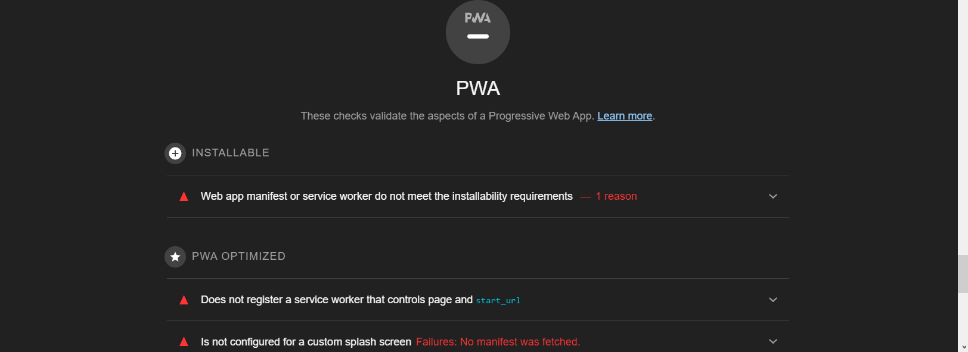

1. **Arasaka Corporation Website Lighthouse #8**

The Arasaka Corporation website uses a variety of security measures to protect visitors' information. The site employs SSL encryption to ensure that all data is transmitted securely. Additionally, the website has been verified by Norton SafeWeb and McAfee SECURE, which are two of the most trusted names in online security. These measures provide a high level of protection for users, ensuring that their personal information is safe when browsing the site. The website also has an ECC CA-3 Certificate, which provides an additional layer of security by verifying that the site is operated by a legitimate company. Lighthouse performance is good with a score of 96/100.

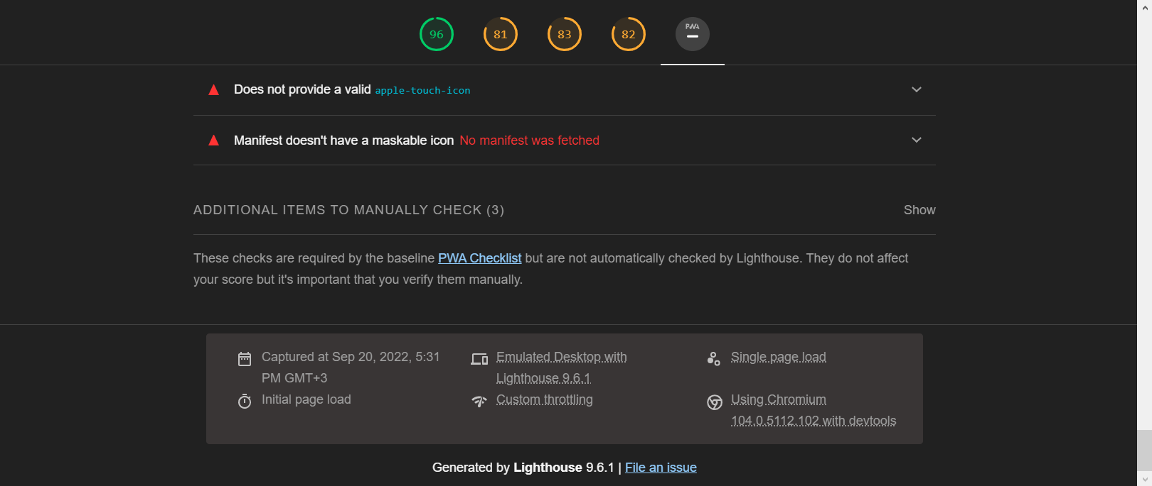

1. 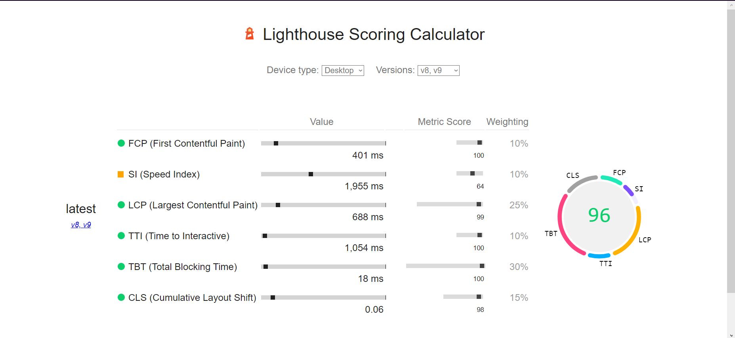**Arasaka Corporation Website Lightouse Scoring Calculator**

**References:**

**Bibliography**

<https://cyberpunk.fandom.com/wiki/Arasaka#Main_Intent_&_Services>

<https://www.linkedin.com/company/arasaka-corporation/mycompany/>

<https://cyberpunk.fandom.com/wiki/Arasaka>

<https://cyberpunk.fandom.com/wiki/Relic>

<https://cyberpunk.fandom.com/wiki/Diary_(117-121/77)>

<https://web.dev/performance-scoring/?utm_source=lighthouse&utm_medium=devtools>

<https://web.dev/performance-scoring/>

<https://cyberpunk.fandom.com/wiki/The_Relic_-_why_all_the_fuss%3F>